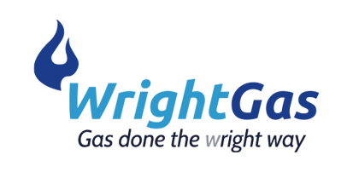

COMPLAINTS
POLICY

We always endeavour to provide the best service and products for our customers. However, on rare occasions, we recognise that there may be times where our customers may not be completely satisfied.
To ensure we are able to put things right as soon as we can, please read our complaints procedure below and we will respond promptly to ensure complete satisfaction.
As soon as possible after the completion of the works, please inspect the work to ensure everything has been carried out to our usual high standards.
In the unlikely event there is anything you are not completely satisfied with, please contact us as soon as you can in order that we can rectify any problems as soon as possible.

Our Procedure
Either call us on
07746 942 768
Or write to us at
Wright Gas (Scotland) Ltd
22 Warlock Road
Bridge of Weir
PA11 3PZ
(please request proof of receipt if posting)
Or email us
Jamie@Wrightgas.co.uk

We aim to respond within 2 days of receiving your complaint and where possible, will provide you with a date to remedy any issues raised.
Where we are unable to resolve your complaint using our own complaints procedure, as a Which? Trusted trader we use Dispute Resolution Ombudsman for dispute resolution. In the unlikely event that we cannot remedy your complaint to your satisfaction you may wish to refer your complaint to them. If you wish to do so please contact Which? Trusted traders in the first instance on 0117 456 6031.
TTF11 Version 5 December 2018

